- Internship Name : Data Analysis
- Task Name: Task 11: Combining Datasets in Pandas using merge(), join() and concat()
- Your Name : Shubhangi Naresh Khonde
- Internship Organization :
- Date:

1. Objective
To practice combining two related datasets in Pandas using merge(), join() and concat(), and to understand when each function should be used.

2. Tools Used
- Python 3
- Pandas library
- VS Code (Jupyter Notebook)
- GitHub (for submission)

3. Datasets
Two related datasets were created, linked by the common column customer_id.
customers (5 rows)
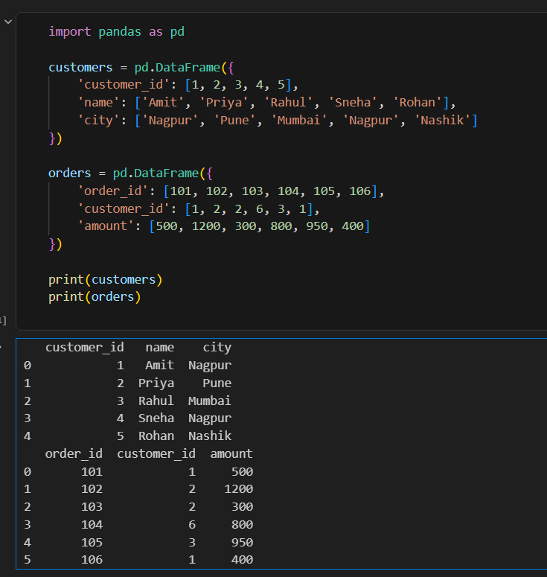
Note: Customer 6 appears in orders but not in customers. Customers 4 and 5 have no orders. This was done deliberately to show how each join type behaves.

4. Merge()
merge() combines two DataFrames based on the values of a common column, similar to a SQL JOIN.
python
pd.merge(customers, orders, on='customer_id', how='inner')
Type | Behavior | Result
inner | Keeps only matching rows | 5 rows (customers 1, 2, 3)
left | Keeps all customers; fills NaN where no order exists | 7 rows (Sneha and Rohan have NaN)
right | Keeps all orders; fills NaN where no customer exists | 6 rows (order 104 has NaN name and city)
outer | Keeps all rows from both tables | 8 rows

Using indicator=True in the outer merge adds a _merge column showing the source of each row: both, left_only or right_only. Customers 4 and 5 were left_only, and order 104 was right_only.
Observation: The order_id and amount columns became decimals (101.0, 500.0) in the left and outer merges because NaN values force Pandas to use the float type.

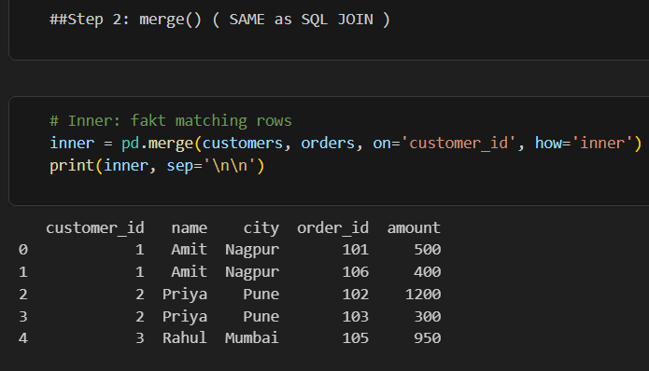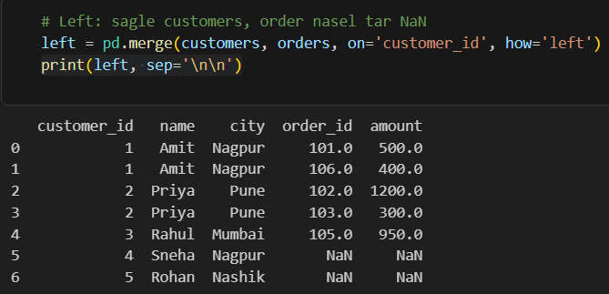

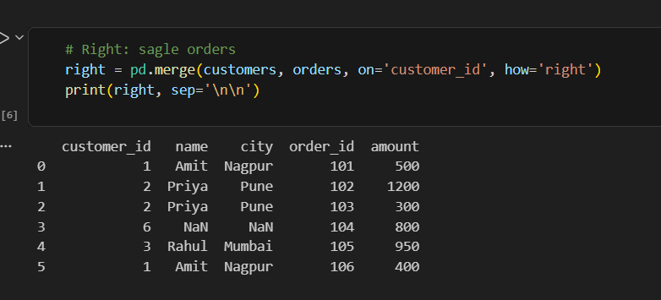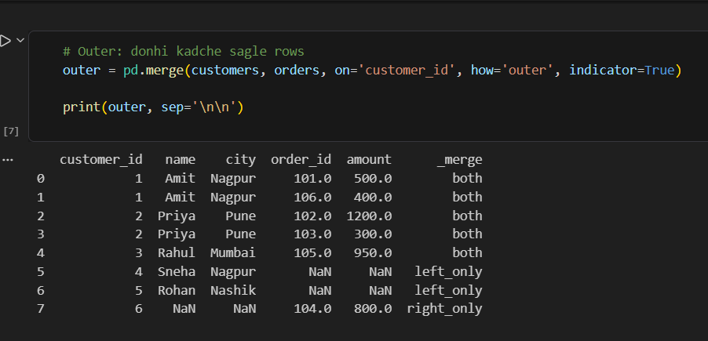

5. Join()
join() combines DataFrames using the index. The customer_id column was first set as the index.
python
cust_idx = customers.set_index('customer_id')
ord_idx = orders.set_index('customer_id')
joined = cust_idx.join(ord_idx, how='left')
- The left join kept all 5 customers, and Sneha and Rohan got NaN for order details.
- The inner join with lsuffix and rsuffix kept only customers who have orders.
- The suffix parameters are used to avoid conflicts when both DataFrames have columns with the same name.

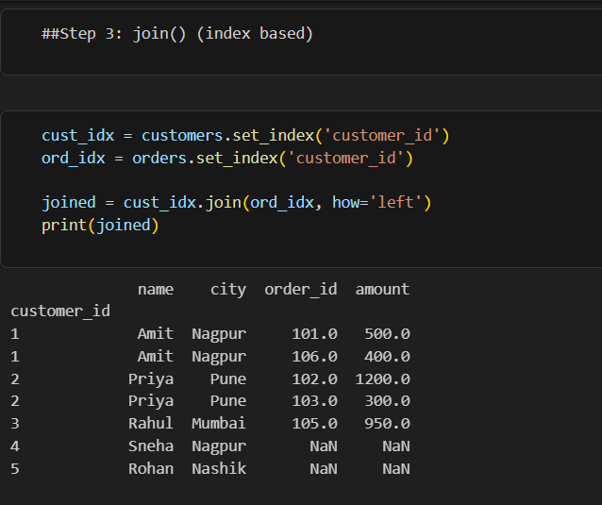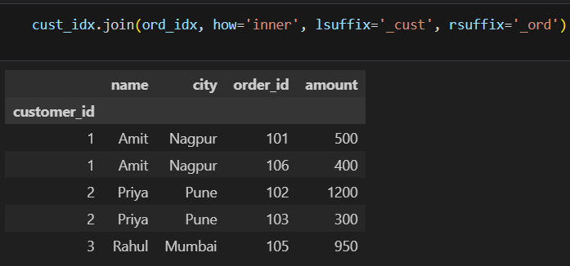

6. concat()
concat() does not match on values. It simply stacks DataFrames together.
- Vertical (axis=0): Two new customers (Neha, Karan) were added below the existing customers using ignore_index=True. The result had 7 rows with a fresh index from 0 to 6.

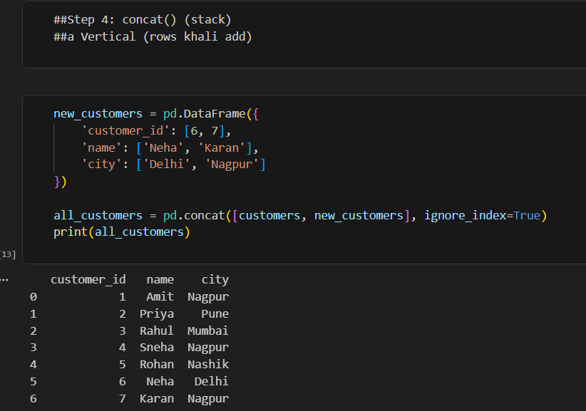

- Horizontal (axis=1): customers and orders were placed side by side. Rows were aligned by index position, not by customer_id. Because orders has 6 rows and customers has 5, the sixth row shows NaN for the customer columns. The customer_id values in the two halves do not correspond, which shows that horizontal concat is not suitable for relational joining.

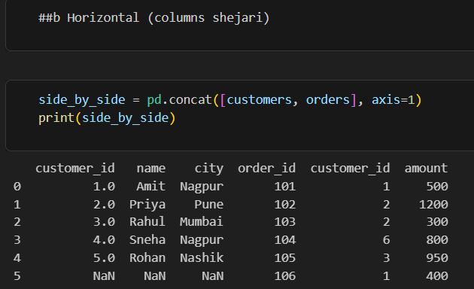

- Using keys: keys=['old', 'new'] created a hierarchical index that labels which rows came from which DataFrame.

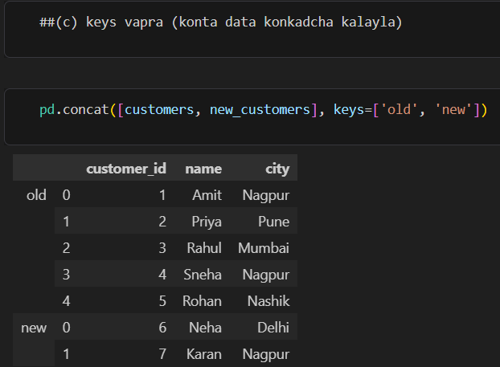

7. Extra Analysis
After an inner merge, the total order amount per city was calculated:
python
merged.groupby('city')['amount'].sum()
Customers who never placed an order were identified using a left merge with indicator=True, then filtering _merge == 'left_only'. The result was Sneha and Rohan.
City | Total Amount
Mumbai | 950
Nagpur | 900
Pune | 1500

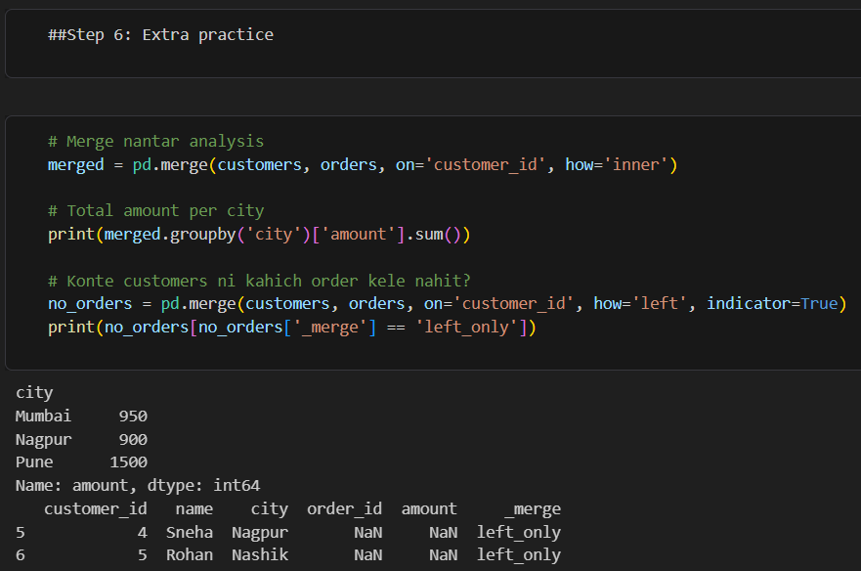

8. Comparison
Feature | merge() | join() | concat()
Combines based on | Column values | Index | Position / axis
Join types | inner, left, right, outer | left (default), right, inner, outer | Stacks only
Best used for | SQL-style joins on a key column | Quick joins when the index is already set | Appending rows or placing columns side by side
Handles unmatched rows | Yes (NaN) | Yes (NaN) | Aligns by index, may create NaN

9. Conclusion
- merge() is the most flexible and is best when two tables share a key column.
- join() is a shorter syntax for joining on the index.
- concat() is best for appending datasets with the same structure (for example, new rows) and not for relational matching.
- Choosing the right join type (inner, left, right, outer) depends on whether unmatched rows should be kept or dropped.
- Using indicator=True is very helpful for finding unmatched records.

